

**School of Science and Technology**

**CSD3999**

**Final Year Project**

**Autumn/Winter term**

**2016/2017**

**Date:** Monday 1st May 2017

**Supervisor:** Franco Raimondi

**Student Name:** Daniel West

**Student ID Number:** M00437276

**Campus:** Hendon

**Title:** Pi-Nav – A Parking Sensor System Using a Raspberry Pi

**School of Science and Technology**

Student Name: Daniel West

Student ID Number: M00437276

Module number: CSD3999

**I hereby confirm that the work presented here in this report and in all other associated material is wholly my own work. I confirm that the report has been submitted to TURNITIN and that the TURNITIN results are on CD attached to this report. I agree to assessment for plagiarism.**

Signature……………………………………………

Date……………………………………………………

**Table of Contents**

Acknowledgements 4

Abstract 4

Chapter 1: Introduction 5

Background 5

Target Audience 5

Objectives 6

Report Structure 6

Chapter 2: Literature Review 7

Pre-existing Projects 7

Relevant Technologies 9

Chapter 3: Design 13

Requirements Specification 13

Hardware Design 13

Software Design 17

Chapter 4: Implementation 21

Initial Stages 21

Component sourcing 21

Hardware Configuration 21

Software Development 22

Chapter 5: Evaluation 24

Testing and Results 24

User Evaluation 24

Chapter 6: Conclusions 26

Summary 26

Future Work (Extensions) 26

Personal Reflection 27

References 28

Appendices 29

Appendix A: Sourced Components 29

Appendix B: Full Python Code 30

Appendix C: Participant Feedback Form 32

BCS Self-Assessment Grid 34

# **Acknowledgements**

Throughout this project, I have received notable help from my supervisor. We had meetings where any technical issues were resolved and any other queries regarding the project were answered. My supervisor donated a Raspberry Pi for this project which was the one of the most significant components but all other components needed for this project was sourced individually.

# **Abstract**

This project developed a parking sensor system for the intended use of first time car owners or classic car owners. The project developed a compact hardware configuration based on the deployment of a Raspberry Pi and developed a graphical user interface (GUI) using the Python programming language. The evaluation of the system involved both unit testing to test functional success and user testing to gain analytical feedback about the system. Further extensions are mainly focused on the GUI by developing additional features to improve the systems functionality. The end result for future development would be to achieve the mapping of the current system on to a full-scale vehicle, however, for this project the prototype has been developed to achieve this objective theoretically.

# **Chapter 1: Introductio****n**

## **Background**

The motoring industry is consistently developing with vehicles now being produced with intelligent computerised systems to improve driving experience. The majority of vehicles are sold with in-built sat-nav and parking sensors as standard but the new frontier of motoring is to develop fully independent self-automated vehicles. “Intel expects the driverless market to be worth as much as $70bn by 2030” (BBC News, 2017). With the progression of technical advancements with modern vehicles, there is an increasing gap in the market to introduce these types of technologies to older vehicles. This project exploits this market gap aiming to sell this type of technology to first time car owners who are purchasing their vehicle on a budget or for driver who generally own older cars.

## **Target Audience and Proposed System**

Drivers with older vehicles are isolated from modern technologies found in new vehicles. The University of Buckingham (2014) found that in 2013, the UK used car market recorded a sales figure of 7.4 million following from a prolonged financial recession in 2006. The technologies found in new vehicles are designed to improve not only the drivers driving abilities but to improve the quality of the driving experience altogether. The isolation of these technologies both hinder driving experiences for drivers with older vehicles and increases the difficulties of driving as there is no technology to assist them. Pre-existing technologies for this purpose are suitable for the targeted audience however the cost to install these technologies would be significantly more expensive than the system being built in this project. Each of the technologies must be purchased and installed separately inducing a higher budget for first time drivers.

The project will aim to produce a system that can be easily installed across multiple vehicles and will aim to achieve this within a low budget. Even though there are currently technologies available for this purpose e.g. TomTom sat-navs and a range of different parking sensors, each component is purchased individually and then installed individually inducing a higher cost and increase in time to complete the installations. The system in this project will aim to combine technologies under one infrastructure and will also aim to simplify the installation process. The design of this device will reduce both purchasing costs and installation costs and will also allow for a range of extensions to be implemented after this project.

## **Objectives**

For this project, a prototype of the system shall be produced rather than a fully developed product due to lack of funding and time restrictions. Two features will be aimed to be developed within this project, firstly a parking sensor system to both assist the driver and improve their driving skills and secondly a sat-nav to assist driver navigation. The two features will then be integrated under one system with the aim of having a GUI for the user to interact with the system. The hardware used in this project will reduce the total cost of the device which fulfils the target of maintaining low affordability.

## **Report Structure**

This report shall firstly explore pre-existing projects and the technologies being implemented in this project in a literature review. The report will then discuss and set the design requirements specified for this project and will detail the hardware infrastructure and the proposed software design with diagrams and sketches. An account of the implementation of the project will then be documented in this report including relevant pictures and screenshots. An evaluation of the project will then be discussed with the evaluation involving both results from unit testing and user evaluation. Finally, the conclusion will summarise the projects successes and limitations, explain possible extensions for future work extracted from the results from the evaluation process and a personal reflection of the project will be discussed. Any citations used throughout the report will be recorded under the references section of this document and an appendices section will be provided for additional material.

# **Chapter 2: Literature Review**

To obtain an in depth and detailed knowledge for the project, pre-existing projects and literature regarding different areas of this project must be explored and considered before proceeding with any major developments in this current project. Producing a literature review will highlight similarities between this project and others and will also analyse different styles of implementation. The literature review will bring new design ideas that will impact and enhance this project as the design will be produced and adapted according to ideas brought forward from the literature review.

## **Pre-existing Projects**

It is important that pre-existing designs and projects are considered before the developing stages of this project for two main reasons. Firstly, it is important to explore all design aspects for this project because initial design ideas when beginning a project are still at a raw stage and can still be open to a range of changes. Exploring pre-existing projects will allow the consideration of other structural designs and styles of implementation towards both the hardware and software used in the project. Secondly, pre-existing projects will indisputably hold similarities towards this project and therefore a process of refinement towards the designs and the implementation of this project must be completed before any developing stages are initiated.

In terms of this project, there are only a few pre-existing projects that closely produce a similar system to the system being built. Two pre-existing projects are to be considered starting with Blythe (2013) who developed a parking camera with a distance sensor. Blythe’s system is controlled by a Raspberry Pi, uses a webcam to visualise the area being measured and a distance sensor to measure the proximity of objects in the area being measured; this is displayed on a 2.2 inch 18-bit colour TFT LCD display. Blythe’s project has some similarities to this project. Firstly, in terms of hardware, Blythe uses a Raspberry Pi to control the system and uses a form of distance sensor to detect object proximity. Blythe also chose to use python to program the system which is the program that has been chosen for this project. The idea of using a webcam to visualise the area being measured is a design that was not previously considered. However, the implementation of a webcam for visualisation purposes is a design that could be applied as an extension to provide more accuracy for the parking sensor system. The structural design is where the difference occurs between Blythe’s project and the project being undertaken. Blythe’s project in terms of a functional structure is sufficient for the project i.e. the structure design deployed by Blythe is a structure that functions as expected. However, Blythe’s structure is not flexible regarding application as it seems that the adopted structure will only function in one particular setup. This project will aim to create a structure design that will enable the parking sensor system to be easily deployed and adapted across multiple platforms. Blythe’s project is an example of a well-executed design to achieve the desired outcome of this project and uses hardware and software similar to this project. The webcam idea can be extracted from this project and is a design idea that has been considered but ultimately the projects similarity dissolve with the structural designs.

Another project closely similar to this project that has significant relevance is the parking sensor system developed by Amjad (2015). Amjad developed a system that is controlled by a Raspberry Pi, uses ultrasonic sensors to measure object proximity and uses webcams to visualise the drivers’ blind spots. Both Blythe’s project and Amjad’s project are similar to the current project due to similar hardware being used, however the project being undertaken is more closely linked to Amjad’s project. The similarities come in the form of a Raspberry Pi being used to control the system, the use of distance sensors, specifically ultrasonic which this project will implement, the use of cameras to visualise the measured area and a form of display to project the cameras feed. Furthermore, Amjad’s project states that the programming was executed using python which is likewise for both this project and Blythe’s project. Amjad’s description of the system does not state a clear structural design but indicates that the system is being installed against a form of DC motor powered rover to replicate a car. Amjad’s project differs in the purpose of the parking sensor system as Amjad states that the sensors are designed to control the DC motors thus enabling the parking procedure to become automated. Distinctly, this project implements the sensors for the individualistic purpose of measuring the distance between the sensor and the object in question. The representation of the sensor detection will come in the form of both a visual aspect and an audio aspect. The parking sensor system being developed in this project will simply aid the user when in the situation of parking, meaning that the user still has full control over the procedure but will have assistance from the system.

## **Relevant Technologies**

In this project, there are three fundamental elements that have pivotal importance in the design of the parking sensor system. These elements are the implementation of the Raspberry Pi, the deployment of ultrasonic sensors over other sensors and the decision to use python programming to compose the software running on the system. The most significant design aspect of this system is the implementation of the Raspberry Pi to control and power the system.

The Raspberry Pi is a small-scale Linux computer designed for a range of applications and systems and is a popular piece of hardware due to its low affordability and its flexibility to be used for multiple purposes across multiple differing projects. Girling, G and Upton, E (2013, pg. 5) accounts his experience with computing during his degree in the late 1970’s and remarks how the Raspberry Pi is considerably more advanced than what was used in the past thirty years. Girling’s book is distinctly written for learning purposes and follows a layout of a tutorial manual. However, Girling’s book does contain a foreword section containing a passage written by Eben Upton, founder and CEO of the Raspberry Pi Foundation. Eben’s passage describes his views on why the Raspberry Pi has become successful and explains his intended purposes for creating the Raspberry Pi. Eben states that the Raspberry Pi was and still is designed for the purpose to teach and encourage children to learn to program. The desire to encourage children to learn programming through the Raspberry Pi in Eben’s opinion derived from children’s inaccessibility to technologies such as the Raspberry Pi which was diminished by the development of games consoles and family PC’s. However, Eben does note that the Raspberry Pi is being used for purposes other than teaching children to program and demonstrates the flexibility of Raspberry Pi. Eben states that he is aware that only around 20% of all Raspberry Pi’s produced end up in the hands of children and lists off some projects that have been completed with the Pi. Some of these projects include enabling mobile phones to open garage doors, building car computers, to control heat and pressure in breweries and bakeries etc. This foreword by Eben is an indisputable demonstration of mainly the Raspberry Pi’s capabilities to be adapted to a wide range of different projects and is also a good example of its low affordability as the intended audience for the Raspberry Pi are children and therefore its low affordability is critical to meet the demands of the target audience.

The decision of what programming language to deploy in a project is fundamental to the outcome of the project. Choosing what programming language to use is mostly dependent on the developer’s level of skills and expertise. Some developers will choose programming languages due to previous experience and familiarity but sometimes the choice of programming languages is determined by the purpose of the project and by what hardware is being used. Usually, the hardware infrastructure of a project does not hold significant influence over the choice of which programming language is deployed but the developer must take into consideration what programming languages work best with the chosen hardware. Despite the developer having more experience in other programming languages, the deployment of other unfamiliar programming languages could be better suited for the project in question. For this project, the decision to use Python was determined through its high compatibility with the Raspberry Pi. Despite most programming languages being compatible with Raspberry Pi, Python is a high-level programming language designed for both highly skilled and beginner level programmers. Norris, D (2014, pg. 2) covers a wide range of projects that involve the Raspberry Pi and follows a narrative style explanation throughout each of the projects. In the introduction, Norris firstly reviews and explains the Raspberry Pi, breaking down each component of the Raspberry Pi and explaining how it works in detail. He then goes on to review the software environments that can be used on the Raspberry Pi such as Raspbian. Lastly, he reviews and explains his decision to use Python. Norris states two major beneficiary factors towards using Python, firstly he states that Python is a programming language designed to be easy to learn and to deploy. He states that most beginners can start to use it immediately without any major troubles. Python is designed to simplify code readability which makes programming in Python easier in two aspects, firstly when writing the code, the code will make more sense logically which in turn will make it easier for the programmer to understand their code. Secondly it makes debugging the code an easier process as the programmer will be able to easily locate the error and solve it with ease. Norris also states that another good design of the Python programming language is that Python encourages the programmer into the creation and usage of modules that can be reused throughout the code. This module re-usage design means that programming time will be reduced as the programmer will not have to continually re-invent new modules. The simplistic design collaborated with its attributes similar to high level languages and its high compatibility with Raspberry Pi means that the Python programming language is for this project the most suitable programming language to be deployed.

The decision on what type of sensor to deploy does not drastically change the rest of this projects design but does hold a significant impact on the outcome of the project. As stated previously, the decision to implement Ultrasonic sensors was made due to the desired outcome of this project, to build a parking sensor system. Before concluding to the choice of Ultrasonic sensors, a process of elimination had to be performed to distinguish the differences between other sensors and what was most suitable for this project. Immediately, any type of touch or impact orientated sensor was declined for this project as the system being developed is aiming to avoid any type of collision. The choice of sensors was then refined down to a list of three, an infrared (IR) Sensor, a motion sensor and an ultrasonic sensor. To briefly explain how each sensor operates, an IR sensor detects the intensity of the brightness reflected from an object. IR sensors read black and white values and are usually implemented for robots with some sort of line following purpose. A motion sensor, even though there are many types of motion sensors including ultrasonic motion sensors, will only detect moving objects. Both the IR and motion sensors would have been inadequate for this project. An IR sensor would be effective at detecting the proximity of an object but would perform differently in different environments for example an IR sensor would perform more accurately during the daytime then off a night time. A motion detector, despite there being many types of them, are again inadequate for this project due to reason that it will only detect a moving object which distinctly means that detection for stationary objects is not supported. The decision therefore concluded with the use of an ultrasonic sensor which most crucially will detect both moving and non-moving objects and will not be effected by light intensity. Ultrasonic sensors operate by sending ultrasonic pulses out and waiting for them pulses to be reflected which then provides the measurement of the objects proximity. Everett, H.R. (1995, pg. 91) provides an in-depth discussion and insight into different sensors used for robotics. Everett states that ultrasonic proximity sensors are useful over distances out to several feet for detecting most objects, liquid and solid. Everett also states that versatile ultrasonic ranging systems are for most situations replacing low-cost microcontrollers. This supports the view of ultrasonic sensors being distinctively more suitable for proximity detection amongst other sensors.

# **Chapter 3: Design**

## **Requirements Specification**

The system will be able to detect obstacles through a set of sensors and depending on the object proximity, a sound will emanate from the system as a secondary source of feedback to the user. The closer the object is to the sensor, the faster the sound will emanate and when the object gets further away from the sensor, the slower the sound will emanate. The sound will replicate a beeping sound as firstly this will minimise the distraction towards the user and secondly a short sound will maintain the accuracy of the sensor readings. The system will be able to provide the user with a graphical interface to display the sensors measurement for primary feedback. The graphical interface will primarily display the current measurement reading of the sensor and secondarily have some form of colour display respective of the sensor measurement. The graphical interface should have some element of interactivity although this is not a necessity for the functional requirements. The project will also aim to implement a sat-nav system to initially display the user’s current position and to then allow the user to plan a route from their current location to their specified destination. The parking sensor system will be the primary focus with the sat-nav remaining as a desirable feature to be implemented. The hardware structure must follow a compact design which can be easily mapped onto a full-scale vehicle.

## **Hardware Design**

Using a Raspberry Pi 3 as a central point to control the system, the Raspberry Pi is connected to a Raspberry Pi 7” Touchscreen Display for displaying the GUI. The 7” display screen will be installed into a protective case to prevent possible damage to the screen and will allow the screen to stand freely. The sensors being deployed in this prototype will be a set of HC-SR04 ultrasonic sensors connected to the Raspberry Pi’s GPIO pins through a breadboard. A small portable speaker is then installed into the Raspberry Pi to enable sound effects to emanate from the system. The Raspberry Pi is situated directly behind the display screen with the breadboard and ultrasonic sensor resting behind the display. The entire system is powered from a power bank which will provide optimal power time and will maintain the compactness of the device. When directly using the Raspberry Pi, a USB keyboard and mouse is required to use the system. The project will also aim to implement a Bluetooth GPS Receiver resulting of the fact that the Raspberry Pi model adopted in this project (Raspberry Pi 3) supports Bluetooth connectivity. The Bluetooth GPS Receiver is installed for the purpose to support the sat-nav feature of the device as this will provide the current position of the user. The Raspberry Pi also supports Wi-Fi connection but can be connected to the internet through an RJ45 Ethernet cable. The device will not require internet connection to run the graphical interface rendering the Raspberry Pi’s internet connectivity an insignificant design aspect. A Micro-SD card is deployed to store the python code used throughout 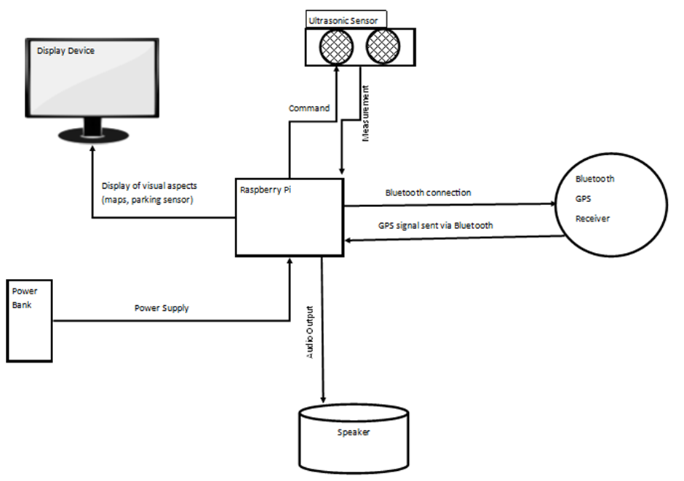the project.

**Figure 1.** A logical System Diagram illustrating the communication of the system being developed in this project

The logical system diagram depicts the communication between each component within the system. This diagram demonstrates the centralisation of the Raspberry Pi and the type of communication that is being sent and received by the different components. Three of the components only have one-way signals between them and the Raspberry Pi. The speakers only require an audio output signal from the Raspberry Pi to produce the required sound. The power bank only supplies power to the Raspberry Pi which then powers the entire system as the Raspberry Pi will distribute a sufficient amount of power to each component. These components are basic in terms of their functionality and in terms of the communication required for them to operate efficiently. The display device (Raspberry Pi Screen) primarily displays the in-built Linux operating system (Raspbian) that is installed onto the Raspberry Pi but is implemented in this project for the purpose of displaying the GUI. Like the previous two components, the display screen only displays the visual output transmitted from the Raspberry Pi but allows direct usage of the Raspberry Pi rather than accessing the Pi through another computer using Putty. Putty is a software used on machines to access other machines using their IP addresses. Putty functions with username and password protection based machines (Nehrbass et al., 2006) and with the Raspberry Pi will communicate through a secure shell (SSH). The ultrasonic sensor and the Bluetooth GPS receiver require a two-way communication with the Raspberry Pi to function appropriately. The GPS receiver will receive a Bluetooth connection from the Raspberry Pi which will be maintained throughout the systems run time. The GPS receiver will then send the received GPS signal to the Raspberry Pi through the Bluetooth connection. The ultrasonic sensor will receive a command from the Raspberry Pi to trigger a pulse out and to listen for the received echo of the pulse which is then sent back to the Raspberry Pi as a distance measurement.

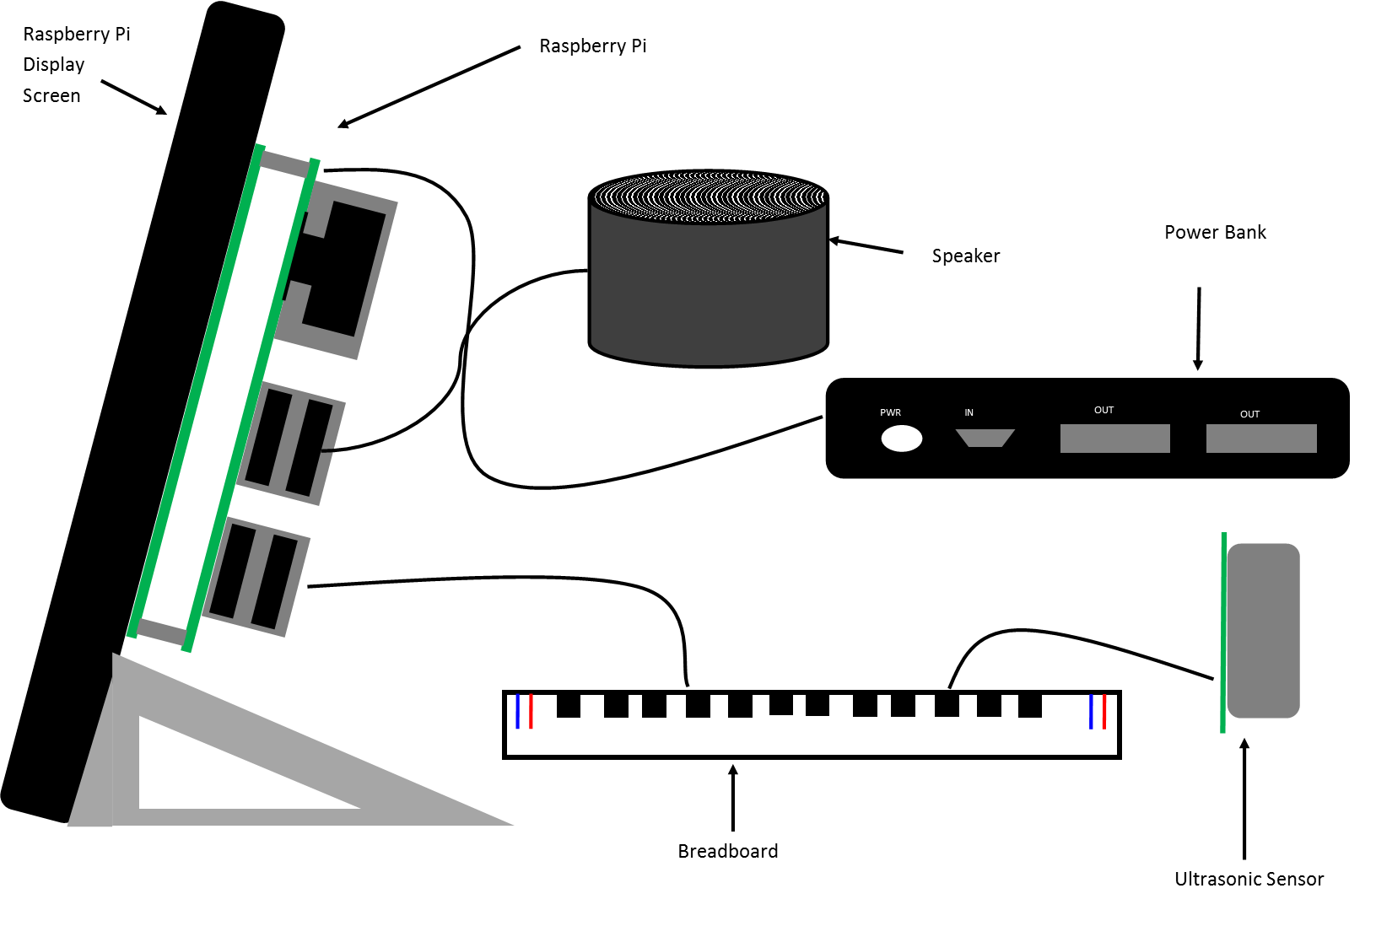**Figure 2.** A Physical Structure Diagram illustrating the hardware structure for this project

The current physical structure diagram demonstrates the hardware structure that is being implemented in this project. The design of the hardware structure has two restrictions, firstly the ultrasonic sensors must be situated at the rear of the structure. The current structure does not necessarily need to have the ultrasonic senor facing the rear of the structure to achieve the desired functionality. However, for the purpose of mapping this structure onto a full-scale vehicle, the sensor would need to be installed at the rear facing side of the device in order to fulfil its desired purpose. The second restriction resides with the display screen as this will be the only form of user interaction with the system. The display screen when mapped onto a full-scale vehicle, would be mounted onto the vehicle’s dashboard as this would be the ideal position for the user to efficiently use the system. The GUI will permit the user interaction and therefore the position of the display screen is pivotal in providing optimal user interaction. The breadboard is used to connect the ultrasonic sensor to the GPIO pins of the Raspberry Pi and although not restricted by positioning constraints, it is still a vital component to the structure as this component allows an efficient connection between the ultrasonic sensor and the Raspberry Pi. The Bluetooth GPS receiver has not been included in this diagram to maintain the closest accuracy to the current build of the structure. The GPS receiver has two restrictions imposed in terms of physical positioning. The GPS receiver would need to be positioned within a close proximity of the Raspberry Pi to maintain an efficient Bluetooth connection whilst also positioned to receive an efficient GPS signal. The hardware structure has been designed to be as compact as possible to enable the structure to be easily installed onto a range of full-scale vehicles. Other components such as the speaker and the power bank do not have positional constraints as these components are easily replaceable for full-scale vehicle installation.

## **Software Design**

Python programming will be applied to the system and the code will primarily aim to implement the parking sensors and will then aim to implement a GUI which includes a graphical representation of the parking sensors and a feature to view the sat-nav. Firstly as a necessity for the project, the graphical interface shall display the measurement reading from the ultrasonic sensor. The measurement readings will be aimed to be displayed in two ways. Firstly, the measurement itself will be displayed to the user, this measurement reading will be positioned in the centre of the display to act as a central focus point for the user. The measurement reading will also be represented through the use of colours, for example, if the measurement is below ten centimetres then the interface shall display a red colour, if the measurement is between ten and twenty centimetres then the interface shall display a yellow colour and any measurement above twenty centimetres the interface shall display a green colour. The sat-nav will primarily display the current location of the user on the map but once a destination has been entered by the user, the sat-nav will display the specified route on the map relevant to the user geographical position. It is important to note that the three sketches explained below are initial sketches for the system and were objectives to aim for throughout the software design. Features and designs that were produced in these sketches that were not implemented in the final design provide future improvements that can be 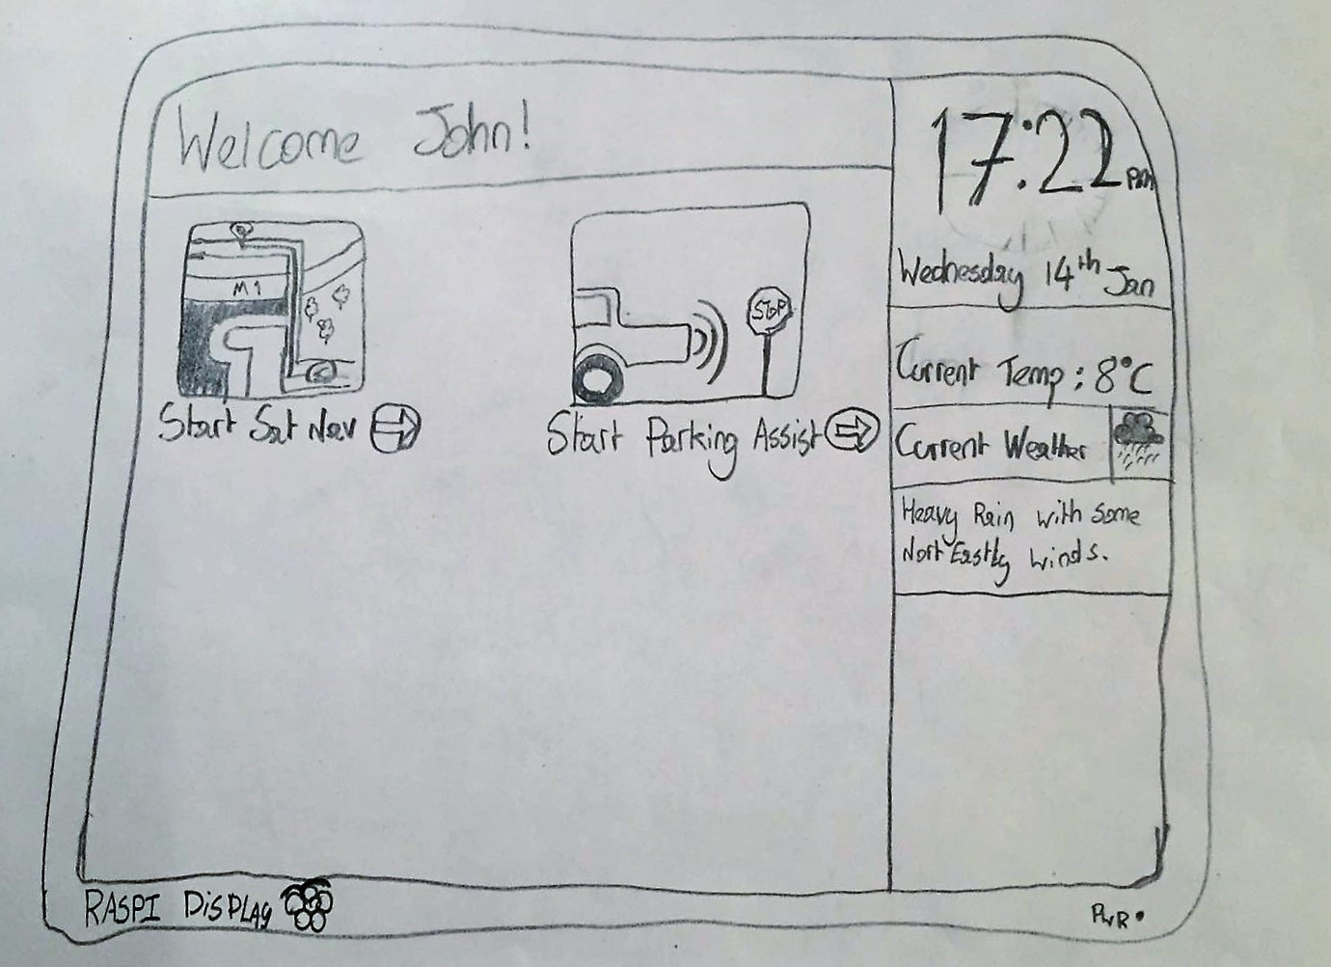applied to the software.

**Figure 3.** An Initial Sketch illustrating the potential design for the software running on the system. This sketch shows a preview of the homepage of the system.

The sketch depicts the homepage of the GUI which provides some user personalisation through a personalised welcome message displayed to introduce the user to the system. The right-hand side of the homepage will contain useful information for the user including the current time, date and weather conditions whilst the centre of the homepage will provide the user access to the main features of the system. The minimalistic design of the homepage means that the main features are represented by two large icons with the name of the feature directly below the icon. As shown in the sketch, the first icon represents the sat-nav feature and the second icon represents the parking sensor feature. The minimalistic design will also enable further development to be produced with ease as more icons can be easily added as more features are developed.

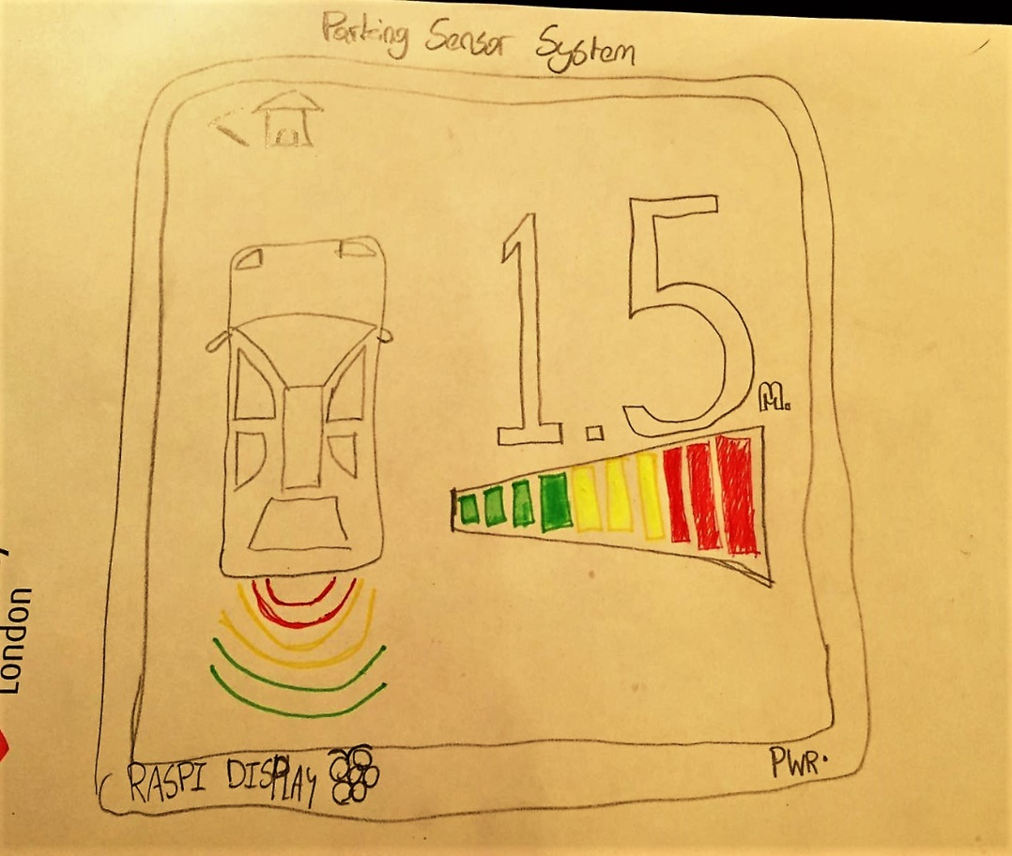

**Figure 4.** An Initial Sketch illustrating the potential design for the parking sensor system display.

The parking sensor system display demonstrates three different styles of representing the ultrasonic sensor measurements unified under one collaborated display to enhance the user’s experience of the parking sensors. The primary display method deployed is through a numerical representation of the distance measurement. The numerical display will reduce the level of confusion that might occur with the other representations, for example a user with a visual impairment such as colour blindness would not benefit from the colour representations and would be dependent on the numerical display. The sketch depicts the colour representation in two formats, firstly the red, yellow and green blocks situated underneath the numerical display. These colour blocks are designed to enhance the numerical display and change according to the current measurement of the ultrasonic sensors. Similarly, the third representation that is situated on the left-hand side of the sketch depicts the vehicle itself with red, yellow and green curved lines placed behind the vehicle diagram. This representation is designed to enhance the other two representations. The vehicle display can give the user a more realistic vision of the sensors functionality and also changes according to the current measurement of the ultrasonic sensor. As previously explained, the red block and the red curved line are displayed for short distances and the green block and curved 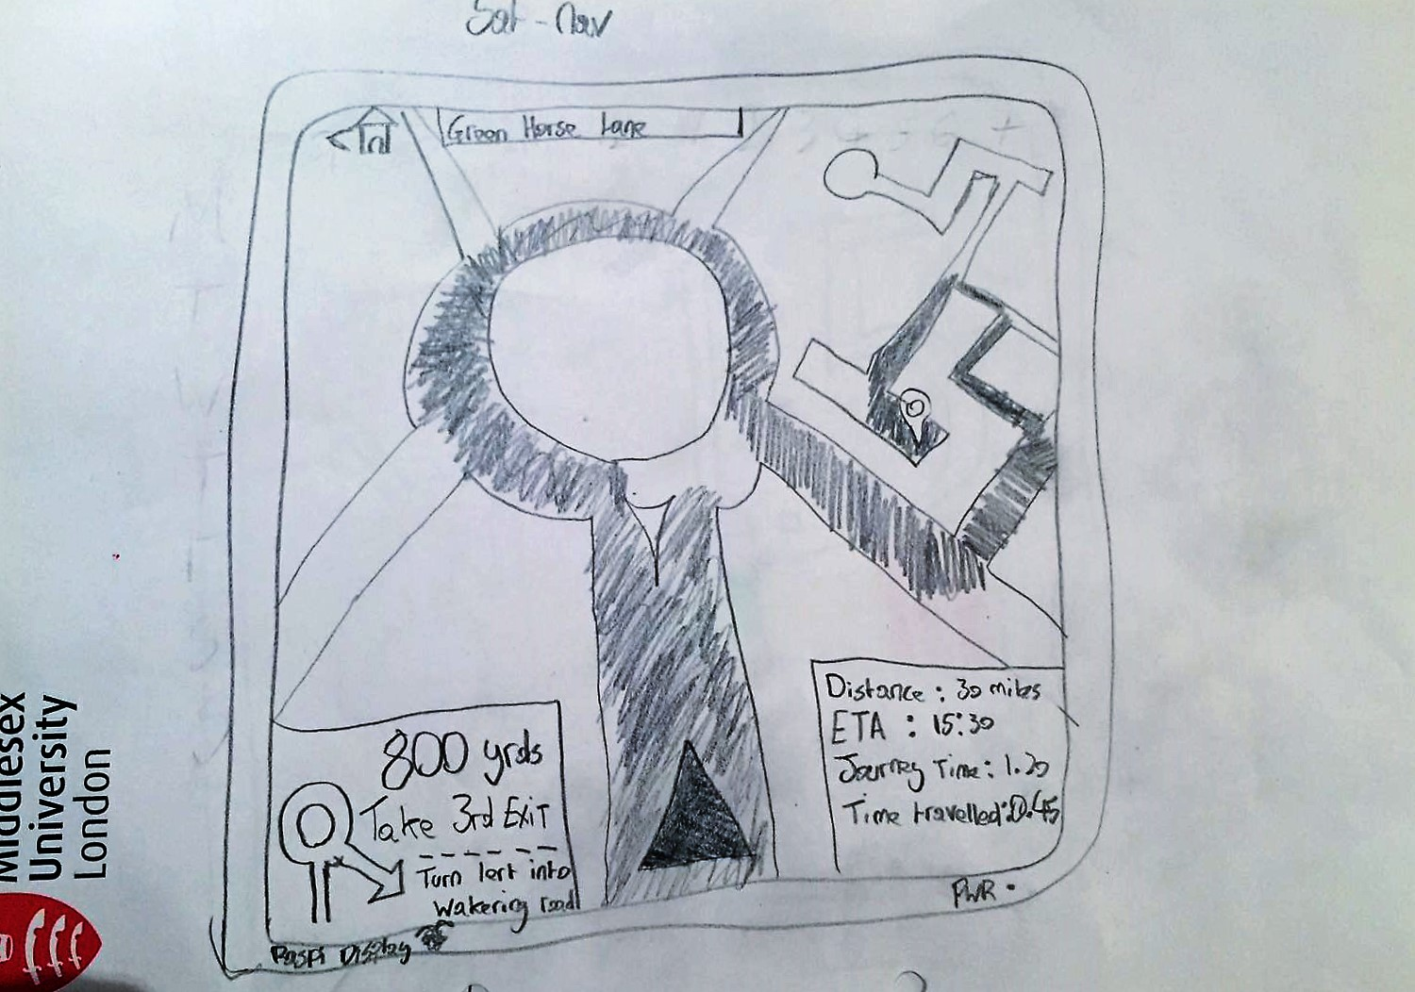lines are displayed for longer distances.

**Figure 5.** An Initial Sketch illustrating the potential design for the satnav display.

This sketch demonstrates the design for the sat-nav feature. The sat-nav feature deploys a standardised design to maintain user familiarity when using this feature. The design will display a small area surrounding the user’s current location and will display a highlighted route upon destination entry. Prior to the user entering their desired destination, the only information that will be provided will be the name of the street that the user is currently at. Once a destination has been entered and a route has been selected, the sat-nav will then display two pieces of information either side of the screen. The bottom-left corner will display information concerning immediate directions to be took by the user whereas the bottom-right corner will contain information about the entire journey for example the total distance of the journey, the expected time of arrival, total journey time and current time travelled. The user’s current position will be depicted by a blue triangular shape, the destination point will be depicted by a red pin shape and the highlighted route shall use a vibrant colour to stand out from the rest of the map which will deploy a subtle colour theme.

# **Chapter 4: Implementation**

The implementation phase of the project was split into two main stages, the hardware configuration stage and the software development stage. There were some prerequisite stages to be completed before the hardware configuration stage could begin and the hardware configuration stage needed to be completed before the software could be developed.

## **Initial Stages**

The implementation phase of the project began with flashing of the Raspbian operating system onto the micro SD card that was being used for the Raspberry Pi. The Raspbian operating system has Python IDLE installed as default thus supporting any executable Python code and would allow the direct usage of the Raspberry Pi if access could not be attained through another machine using Putty. The next stage was to build the physical structure of the device. This involved successfully installing the ultrasonic sensor to the Raspberry Pi’s GPIO pins and to successfully connect an appropriate display screen to suit the purpose of the device for the project.

## **Component sourcing**

Before any installations could be performed, some product research and product sourcing was conducted to ensure that the system would be adopting the most efficient hardware components. The vital components that needed to be sourced were the display screen, the ultrasonic sensor, a breadboard, a portable speaker, a power bank and a keyboard for the direct use of the Raspberry Pi. All of the sourced components can be seen in appendix A. The power bank needed to be compact and portable to firstly maintain the compactness of the hardware structure and to secondly ensure a longer power time for the Raspberry Pi. Due to the speaker only required to permit a beeping noise for the ultrasonic measurements, the quality of the speaker was not a main focus but compactness was again the significant factor considered when sourcing this component. The breadboard was needed to successfully connect the ultrasonic sensor to the Raspberry Pi’s GPIO pins and at the moment does not have a secure installation. As mentioned in the literature review, after a process of elimination, the ultrasonic sensor was decided to be the most appropriate sensor to deploy to achieve efficient measurements for the desired purpose of the project. Finally, the display screen was sourced to firstly allow the direct use of the Raspberry Pi but to also permit the GUI to be displayed.

## **Hardware Configuration**

The Raspberry Pi was mounted directly onto the back of the display screen securing both the connection from the Raspberry Pi to the display screen and to maintain a secure installation of the Raspberry Pi. The ultrasonic sensor was then wired onto the breadboard, then the breadboard was wired into the Raspberry Pi’s GPIO pins allowing an efficient connection of both components. The speaker is installed through the Raspberry Pi’s audio output jack and the keyboard is installed through one of the Raspberry Pi’s four USB ports. The hardware configuration follows a flexible and compact structure to ensure that this system can be easily mapped onto a full-scale vehicle. A casing was sourced and fitted around the display screen to minimise any chance of screen damage and along with the attached Raspberry Pi, is the only part of the structure that is built to a stricter design than the rest of the system.

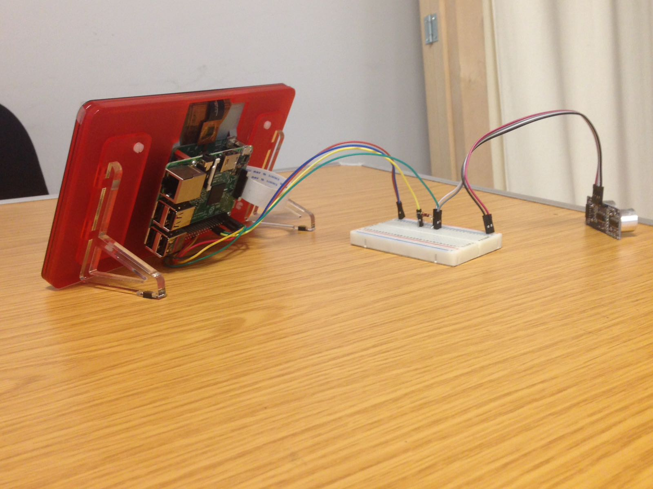

**Figure 6:** The completed Hardware Configuration

The picture presents the completed model and it can be seen as to how this system can be mapped onto a full-scale vehicle. The hardware configuration can be split into three sections, the front section which is where the user will interact with the system through the display screen, the back section which is where the ultrasonic sensor is situated and the middle section is where the connection of both the Raspberry Pi and the ultrasonic sensors is situated. When mapped onto a full-scale vehicle, the front section will be installed where the user can easily interact with the display screen for example on the vehicles dashboard. The back section will be installed at the rear of the vehicle as this will meet the purpose of the project and due to the size of the sensor can easily be installed in this location of the vehicle. The mapping of the middle section of the system onto a full-scale vehicle will be dependent on the type of vehicle upon which the system is being mapped to. However, the flexible structure implemented on the hardware means that this system has a limited number of constraints for full-scale installations. The Bluetooth GPS receiver was not implemented into the current hardware configuration due to time restrictions. The decision to focus on achieving the fundamental objectives of developing the parking sensor because of the limited time scale to complete the project, resulted in the sat-nav feature becoming undeveloped thus the GPS receiver becoming unrequired.

## **Software Development**

The software development stage consisted of two objectives to be achieved. Firstly, the ultrasonic sensors needed to be fully implemented to meet the purpose of the project and secondly a GUI needed to be developed to achieve user interaction with the system. The full code has been included in this report under appendix B. The first objective was to firstly achieve full functionality of the ultrasonic sensor and then to programme the sensor to efficiently measure distance to maintain the desired functionality for the project. The first piece of the code produced was to achieve the basic functionality of the sensor. The GPIO pins used to send and receive the sensors signals are defined to be deployed in later code. The pins are then initialised for the relevant signal type to handle. A signal is then pinged from the sensor and the sensor waits to receive the echo from the pinged signal. Once the signal is pinged a timer is started and when the echo has been received the timer is ended. The distance between the pinged signal and the echo signal is then calculated. Initially the code only printed the measurement once and then ended the code therefore only resulting in one measurement occurring at a time. The next step was to put this singular measurement into a continuous loop that would only be exited through programmer intervention. Once this continuous loop had been implemented, the beeping sound effect then needed to be integrated into the code. The beeping sound was integrated through the importing of the Pyglet library (Holkner, 2013) and was then placed in the main loop of the code. At first, the beep sound played after each measurement but was not linked to the measurement proximity for instance the closer the obstacle was detected the beep remained at the same pace when the beep should have become faster. Once the beep sounds were linked to the measurement proximity, the code to fully implement the sensor was complete and the coding then moved forward to creating a GUI. For this, the code adopts a default Python library designed for creating simple GUIs called TkInter (Python, 2016).

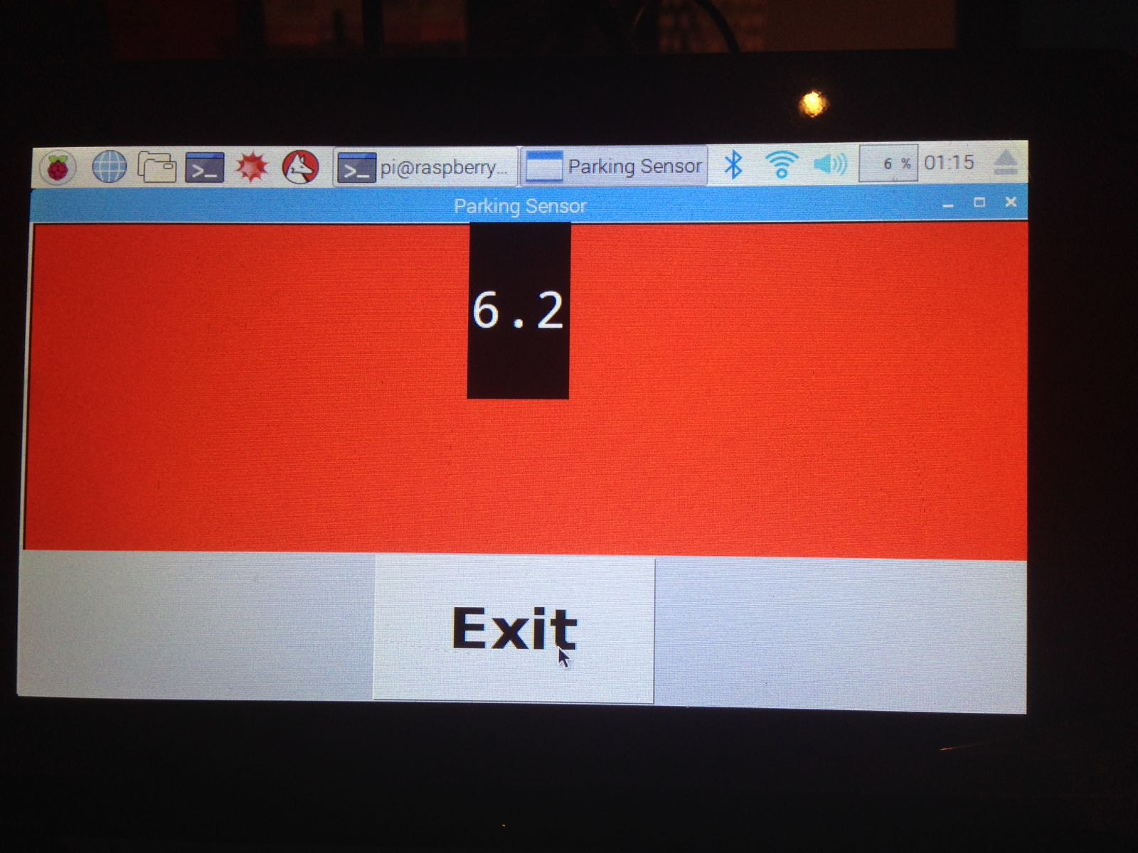

**Figure 7:** The current design of the GUI (GUI).

The current design adopts some of the ideas described in the initial software designs but have a much simpler structure. The red, yellow and green colours have been used to enhance the distance measurement display and are visible in the background of the GUI. The distance measurement is the primary focus as this displays the number of the measurement detection. The user has the option to exit the GUI by pressing an ‘Exit’ button which will stop the ultrasonic sensor measuring and will close the GUI. Currently, the GUI can only be accessed through the Linux command line but this can be an improvement for future work. As discussed in the hardware configuration section, the sat-nav feature was not implemented due to the time restrictions which led to the decision of focusing on achieving the fundamental objectives which resulted in the parking sensor feature being the only feature to have been developed.

# **Chapter 5: Evaluation**

## **Testing and Results**

The system was tested through iterative tests conducted throughout the software development stage of the implementation phase. The iterative tests applied unit testing to test the functionality of the entire system. The code was repeatedly executed at various stages of development to test for any debugging issues and to test for expected behaviours of each component. The successfulness of the hardware configuration was tested when the code to achieve the basic ultrasonic sensor functionality had been produced. Once the code for the sensor functionality had been executed, this tested for both syntactical correctness and for hardware configuration successfulness. The hardware configuration proved to work successfully and each component functioned as expected. Code executed after this point was to then test the system again for syntactical correctness and for expected outcomes of the code. Most of the results from the iterative tests highlighted debugging issues in the form of indentation errors and syntactical correctness. The highlighted issues identified through Python’s interpreter were resolved and the code was re-executed until the expected outcome had been implemented successfully. Iterative tests allowed the viewing of progression forming within the GUI and meant that designs were distinctly produced based on the current design progression. Through the use of iterative tests, the development of the system was successfully achieved and the fundamental design aspects from the initial design sketches were maintained.

## **User Evaluation**

To obtain analytical feedback regarding the developmental progression of the system, user testing was conducted. The participants were briefed on the purpose of the system and were given a demonstration of the working model. After the participants had interacted with and experienced the system, they were given a feedback form which can be seen in appendix C. The feedback form asked the participants a range of different questions regarding their thoughts about the current system and potential improvements for the system. Six participants were selected for the user evaluation, three of the participants currently own a vehicle and have extensive driving experience, two of the participants do not currently own a vehicle and have no driving experience and one participant does not currently own a vehicle but has some driving experience. The participant’s identities have been made anonymous throughout the user evaluation process. The first question on the feedback form asked the participants to either recall the first car they owned or imagine if they currently owned their first vehicle and were asked if they would use the current system in their first owned vehicle. The results confirmed that 83.3% of participants would adopt the current system into their vehicles which suggests an overall satisfactory design has been achieved. This suggestion was confirmed through further questions in the feedback form. Participants were asked to rate the current system on a scale from one to ten on both the physical design i.e. the hardware configuration, and software design i.e. the GUI. Both the hardware and software design received a rating of eight or higher confirming that the overall design of the system was implemented effectively. All of the participants stated that the colour display implemented to enhance the distance measurement successfully enhanced the system as expected. Participants noted that the display made the current system unique to other products and that the feedback from the sensor was clear to view and easy to use. The majority of the participants had suggested two features that were the most desired to be implemented into the current system. A multimedia player and the ability to enable mobile phone connectivity was highlighted as the two most desired features. Considering that the project originally aimed to implement a parking sensor system and a sat-nav, the results were surprising in the fact that not many of the participants chose the sat-nav feature to be implemented. Additionally, participants were asked in what way they would choose to improve the parking sensor system. The majority of the participants stated that the most appropriate improvement to make would be to implement sensors for the front of the vehicle as well as the back. Both of these results will have a significant impact for future development as these improvements will have to be considered as well as improvements discovered internally. Participants confirmed that the current system has achieved the objectives for the project with some stating that the system is “very compatible for a vehicle without it”, also stating that they could understand the purpose of having the current system installed onto a “much older vehicle”. Overall, the feedback received from the participants reflected positively against the current system confirming design successes and guiding future development through implementable suggestions.

# **Chapter 6: Conclusions**

## **Summary**

Overall, the fundamental outcomes of this project have been achieved with the parking sensor functionality fully implemented and to have a GUI developed. Enabling user interaction with the system means that the system if required can be immediately installed onto full scale vehicles. The hardware configuration functioned successfully and maintains a compact design. The sourcing of the components was crucial to the outcome of the design for the hardware but the components that were sourced were ideal for the design requirements that were set to achieve the desired purpose of the project. The software development proved to be the more challenging aspect of the entire system development. Producing code to achieve the ultrasonic sensor functionality was a familiar area of coding however, developing the code for the GUI was a newly attempted area of coding and proved to be more complicated than initially expected. Due to time restrictions, the decision was made to focus solely on achieving the fundamental objectives of the project which resulted in the sat-nav feature remaining a feature still to be developed. However, the end result of the system has achieved the fundamental objectives of this project and functions successfully. There are many improvements and extensions that can be implemented in this project for future work.

## **Future Work (Extensions)**

There were many improvements and extensions that could be implemented to the system both in terms of the hardware configuration and the software development. Some extensions originated from the initial design plans for this project and some extensions were discovered through the user testing. The hardware configuration has limited improvements to be implemented but the development of a full prototype would have enhanced the system further. For example installing the current hardware configuration onto a full-scale vehicle would have demonstrated the robustness of both the components individually and the structure as a whole. A full-scale vehicle installation would have provided more realism in the unit testing and user testing stages which could have provided more accurate feedback. The majority of the extensions that could be implemented reside with the software development. An immediate extension that could be made again originates from the initial software design where a sat-nav feature was planned to have been implemented in this project. The sat-nav feature and the parking sensor feature would need to be accessible under one application, implementing the homepage design from the initial sketches. Other extensions discovered from user testing were mainly based on adding more features to the software. Participants suggested that implementing mobile phone connectivity i.e. having the ability to make and receive calls and texts through the system was one of the most desired features to be added to the system. A multimedia player feature to enable the connection of iPods, mp3 players etc. was also suggested to be implemented and added to the current system. Other features were suggested such as adding a radio station tuner feature and adding a feature to enable internet connectivity, however, the multimedia player and mobile connectivity were the two popular features amongst the participants. Participants also suggested improvements to be implemented to the parking sensor system. The main improvement suggested was to implement sensors to the front of the vehicle as well as to the back. Other suggestions included implementing a parking camera for the rear sensors and converting the distance measurement from centimetres to a more appropriate measurement such as inches/feet. A suggestion regarding the current design of the GUI was also brought forward by the user evaluation. A participant had noted that the positioning of the numerical display could be improved e.g. having the numerical display in the centre of the screen. Another improvement that could be implemented in future work that was mentioned earlier in this report would be to have the software open automatically upon switching on the system. Currently, the GUI is only accessible through the Linux command line which is an inefficient method to accessing the system.

## **Personal Reflection**

The project was impacted by time restrictions resulting in some of the objectives of the project being unachieved. The project is open to many extensions and with further development would firstly achieve all of the objectives that was set and would also progress further than the set objectives. This would result in a system that could match standards implemented on currently deployed technologies. The fundamental objectives for this project have been achieved and in terms of producing a product which matches the purpose of the project, the development of the current system has been successful. The hardware configuration achieved the fundamental design aspects that were placed at the beginning of the project and operates successfully as it performs the expected behaviour for this type of system. The project was also impacted by limited funding which restricted the standard of technology that was sourced and implemented in this project. With more funding, the hardware configuration could include a vehicle for the installation of the current system and overall implement more efficient and advanced technologies to improve the performance of the current system. The GUI contains the majority of the extensions in the form of implementing additional features to the system. However, as an initial prototype, the developed system has achieved the fundamental objectives that were produced at the start of the project. The software implements the ultrasonic sensor to measure obstacles accurately and appropriately and permits a graphical representation of the sensor’s measurements to the user, enhancing the user experience and interactivity with the system.

# **References**

Holkner, A. (2013) Pyglet Documentation Index. Available at: https://pyglet.readthedocs.io/en/pyglet-1.2-maintenance/ (Accessed: 27th April 2017).

Amjad, F., Haroon, A. and Hayat, M., 2015. Raspberry-Pi (On-board Computer) Based Intelligent Vehicle Parking System. International Journal of Technology and Research, 3(1), p.27.

Blythe, J. (2013) Raspberry Pi Parking Camera with Distance Sensor. Available at: http://jeremyblythe.blogspot.co.uk/2013/03/raspberry-pi-parking-camera-with.html (Accessed: 10th November 2016).

Everett, H.R. (1995) Sensors for Mobile Robots. Massachusetts: CRC Press.

Girling, G and Upton, E and Upton, L. (2013) Raspberry Pi - A Practical Guide to the Revolutionary Small Computer. Somerset: Haynes Publishing.

BBC News (2017) Intel Buys Driverless Car Technology Firm Mobileye. Available at: http://www.bbc.co.uk/news/business-39253422 (Accessed: 4th April 2017).

Nehrbass, J., Samsi, S., Chaves, J.C., Unpingco, J., Guilfoos, B., Ahalt, S., Krishnamurthy, A., Chalker, A. and Gardiner, J., 2006, June. Interfacing PC-based MATLAB directly to HPC resources. In HPCMP Users Group Conference, 2006 (pp.1). IEEE.

Norris, D. (2014) Raspberry Pi Projects for the Evil Genius. United States of America: McGraw-Hill Education.

Python. (2016) TkInter. Available at: https://wiki.python.org/moin/TkInter (Accessed: 27th April 2017).

The University of Buckingham (2014) 'The Used Car Market Report 2014'. Available at: https://www.buckingham.ac.uk/wp-content/uploads/2014/11/pnc-2014-usedcar.pdf(Accessed: 26th April 2017).

# **Appendices**

## **Appendix A: Sourced Components**

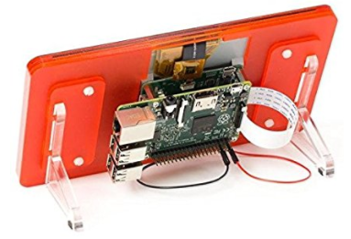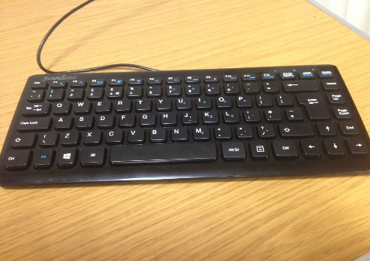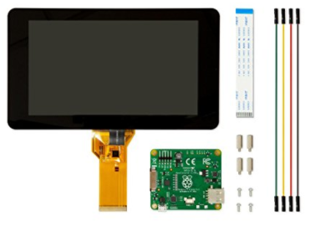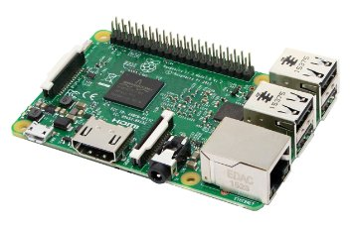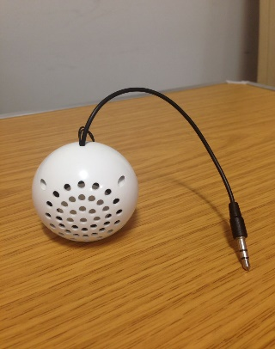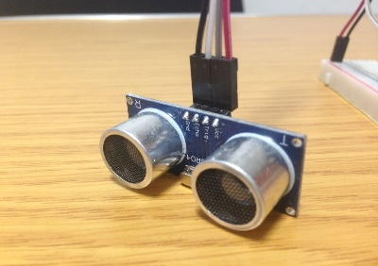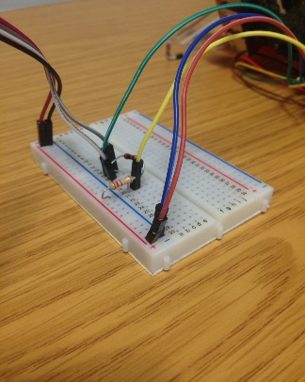

## **Appendix B: Full Python Code**

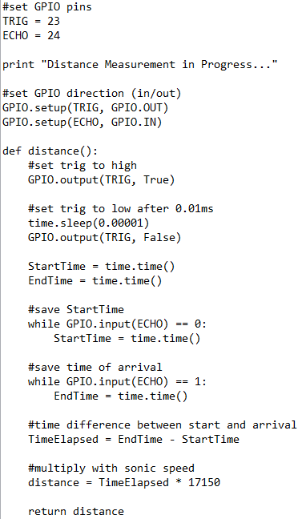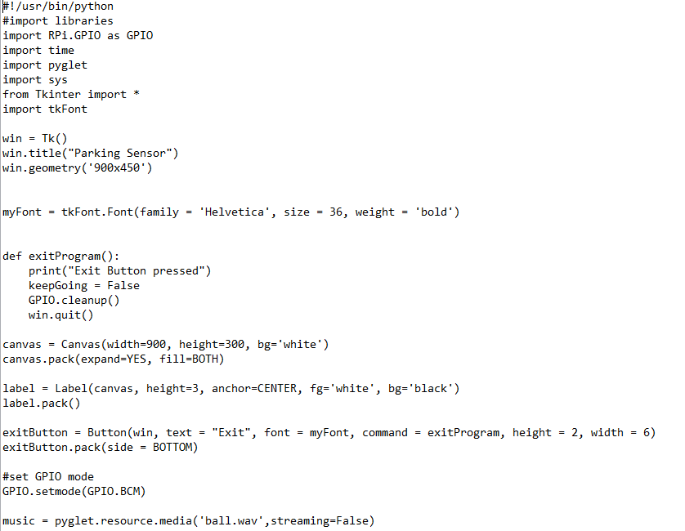

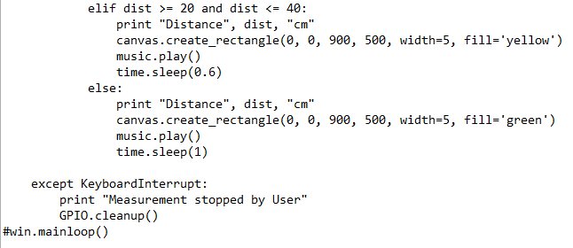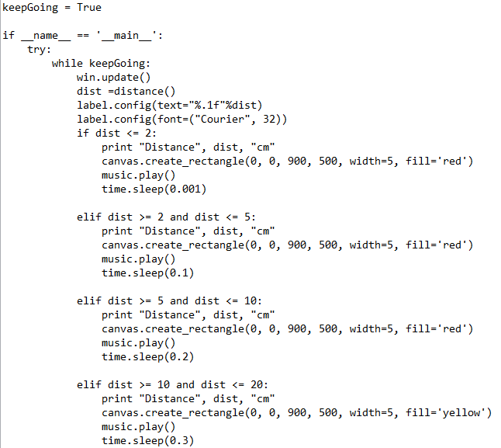

## **Appendix C: Participant Feedback Form**

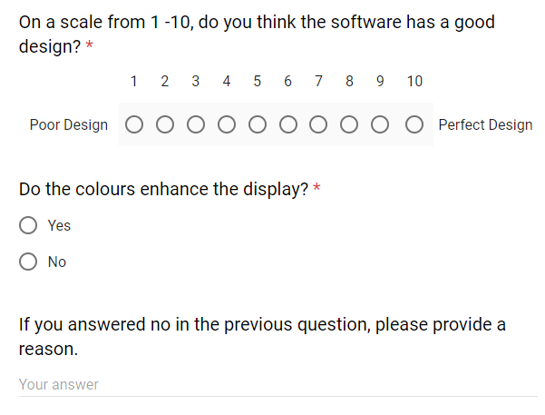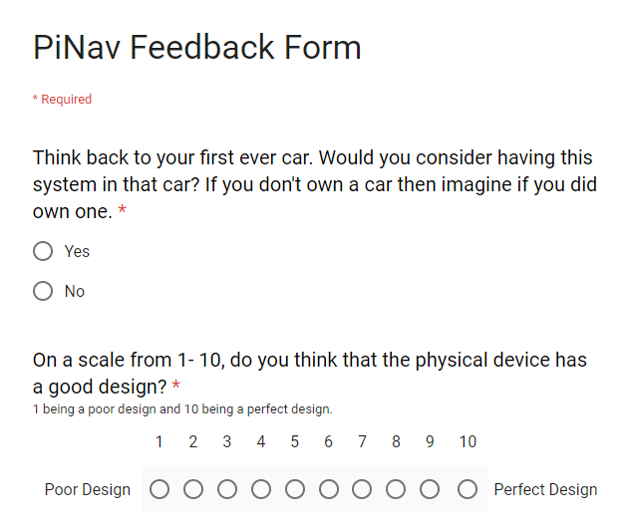

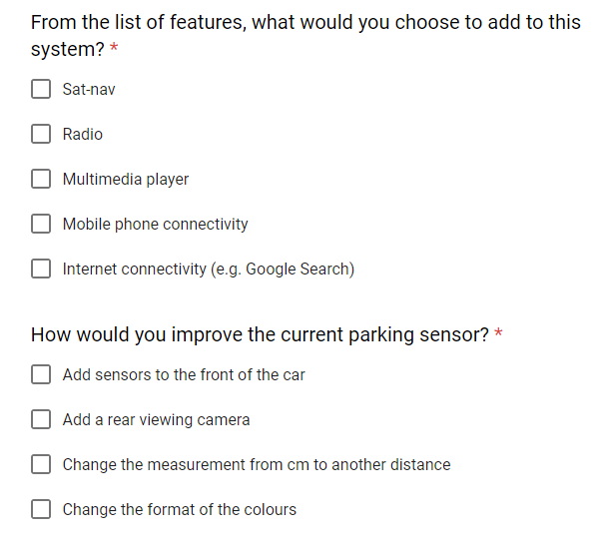

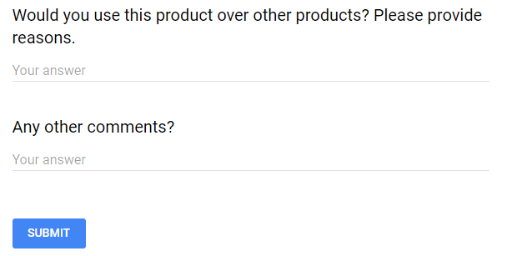

# BCS Self-Assessment Grid

|  |  |
| --- | --- |
| Elucidation of the problem and the objectives of the project (objectives need to be clearly stated and if possible measurable upon completion). | The objectives of this project are to produce a parking sensor system that uses a display for user interaction and is designed to be installed on vehicles isolated from these technologies. |
| An in-depth investigation of the context/literature/other similar products. | The project has conducted an in-depth investigation firstly on pre-existing projects that aim to achieve similar objectives to this project and into the technologies that are being implemented within this project. |
| A clear definition of the problem | The development of technologies within the motoring industry are rapidly becoming more advanced. However, there still remains a large number of vehicles that are isolated from these advanced technologies. This project aims to develop a cost-effective product that aims to unify these technologies under one device which can be easily installed onto to range of different vehicles. |
| A clear description of the stages of the life cycle undertaken (if this is a development project), or the ordering of the project activities. Please note that this refers to a structured approach for deriving a solution, involving a number of stages. It does not imply a sequential development pattern, but rather refers to a focus on the development process and on multiple identifiable phases. | The first stage to the development of the project was to perform a literature review. This identified pre-existing concepts and helped direct the design of the product. Upon completion of the literature review, a design process began where initial sketches were drawn to represent the design of the software and diagrams were constructed to depict the hardware configuration and logical communication between each component. When the design process was completed, the implementation could begin. The implementation phase consisted of building the hardware configuration and developing the software to run on the system. An evaluation of the system was conducted to test for the functional successfulness from unit testing and for analytical feedback from user testing. The evaluation highlighted the successes of the system and also extensions and improvements for future work. |
| A description of the use of appropriate tools and the choice of methods to support the development process, the information gathering and/or the investigation (should also address the range of potential tools/methods and reasons why final selection was made). | The development of the system consisted of two vital components. In terms of the hardware configuration, the Raspberry Pi was designed as a centralised component and therefore had the most significance over other hardware components. Other significant components were there display screen which was required to enable user interaction and the ultrasonic sensor to achieve the most accurate measurement. The software development was created in Python as this programming language holds the most compatibility with the Raspberry Pi. The evaluation of the system was conducted through unit testing to test for functional successfulness and user testing to obtain analytical feedback about the system. |
| A description of how verification and validation were applied at all stages (with a particular emphasis on test plans and their derivation). | The project was structured by four submissions. The first submission was for a project proposal which verified the objectives of the project, the problem definition and the intended system to be built. The second submission consisted of a literature review and a discussion of proposed designs for the project which verified that sufficient research had been conducted prior to the development stages and an initial design had been developed. Iterative tests throughout the implementation stages validated the successfulness of both the hardware configuration and the software development. Both evaluation techniques deployed verified both the successes of the system and the improvements for future work. |
| Consideration of the quality of the solution or findings -- if a product is being developed, it is often expected that it will exhibit the attributes of quality, reliability, timeliness and maintainability    A critical appraisal of the project, indicating the rationale for design/implementation decisions or other choices and lessons learnt during the course of the project. | A fundamental design that was stated in this project was for the hardware configuration to maintain a compact structure which can be easily mapped onto full-scale vehicles. The system developed within this project has achieved this objective through the implemented components. The current design effectively achieves the fundamental objectives of creating a parking sensor that users can experience visually through the display. The power bank component deployed to supply power to the system maintains the compactness of the hardware configuration as well as provide optimal power time for the system. The software functions appropriately according to the sensor and only requires minor adjustments to enhance the performance of the GUI. |
| Evaluation (with hindsight) of the product and the process of its production (including a review of the plan and any deviations from it and self-evaluation of the work). You may also want to consider future work. | The evaluation highlighted both the successes of the development and also improvements to be made for future work. The unit testing confirmed the successfulness of the hardware configuration and confirmed the expected functionality from the software. User testing highlighted improvements and extensions that could be implemented in future work. The majority of these extensions and improvements resided with software as the results concluded that the implementation of more features would improve the system. |
| References | The references consist of books, journal articles, reports and web pages and have been included firstly to validate points made throughout the report and secondly to strengthen the discussions within the literature review. |
| Appendices - technical documentation | The appendices in this report have been included to strengthen explanations throughout the report as the reader can view the appendix that is being explained. |
| Professional projects imply pride in the products that you develop. Please remember to acknowledge all contributions and cite your sources. It is normally necessary to rely on work developed by other people. This can be used to support and advance your argument. Acknowledging the original contributors suggests that you know where to look, what is relevant, and are using it to support your opinion and strengthen your position. | All of the sources that have been cited in this report can be found in the reference section. Throughout the project, I have received notable assistance form my project supervisor. My supervisor mainly assisted me with the software development but also assisted with report write-ups. We had meetings where any technical problems were resolved and any other queries were answered. |
| The quality of presentation | This report has deployed a combination of both appendices and figures throughout. The figures have been used to assist the readers understanding of the what is being discussed the appendices have been included as relevant additional materials. The report has been split into sections, dividing the report by its stages and within these section, the report has been structured with sub-headings. |
| The use of language | The report has been composed in past-tense as this is a reflective report of the project. The report adopts a formal language to maintain professionalism throughout the document. |
| The fact that critical appraisal, rationale, justification and lessons derived from the effort in the final evaluation can be applied to both the product (artefact, solution or result) and the process used to deliver it. | The completion of a literature review before any development processes were started demonstrates that considerable research has been conducted to strengthen the justification for the objectives and purpose of this project. Initial designs demonstrate that considerations for possible designs were included and that a high level of rationale has been applied to the project. The evaluation techniques highlighted both improvements for future work but also highlighted constraints that impacted the development of the project and demonstrates the potential weaknesses that were imposed on the project due to these constraints. |